GOVERNMENT ENGINEERING COLLEGE
THRISSUR

PCCST503 | ASSIGNMENT 2

TECHNICAL REPORT
Design of a Vector Embedding for Capability Composition
Formal representations, compatibility, and compositional reasoning

Submitted By
Manasa M
Roll No. 43
September 2026

1. Problem Definition
Modern natural-language processing moved from symbolic word representations to distributed vector representations with Word2Vec (Mikolov et al., 2013), where words with similar meaning lie close together in a continuous space. This assignment asks a different question: instead of semantic closeness between words, can we capture the functional relationships between the capabilities of an application, i.e. which capabilities can work together, what they require, what they produce, and how they transform system state?
A capability is a reusable operation with a formal description Ci = (Ti, Ii, Oi, Pi, Ei, Ki, Ri, Qi, Reli, Ai, Mi), covering its type, inputs, outputs, preconditions, effects, constraints, resources, cost, reliability, availability and execution mechanism. An application is modelled as A = (S, C, SI, G, R, K). The central task is to design, implement and evaluate a problem-specific vector representation for states, goals and capabilities that preserves the relationships needed to (a) detect compatible capabilities and (b) build complex capabilities from simpler ones.
Planning algorithms (BFS, A*, LPA*, D* Lite) from Assignment 1 are outside the scope; only the representation of the operations is studied here.

2. Design Requirements
The embedding was designed against the nine properties required by the assignment:
- Capability identity: functionally different capabilities must receive different vectors.
- State awareness: the vector should relate a capability to the states in which it can operate.
- Precondition–effect compatibility: Ei ⇒ Pj must distinguish Ci → Cj (compatible) from incompatible pairs.
- Input–output compatibility: outputs of one capability satisfying inputs of another must be representable.
- Similarity vs. composability: functional resemblance is not the same as composability; both must be handled separately.
- Composition: Ci ◦ Cj and C1 ◦ C2 ◦ … ◦ Cn must map to meaningful vectors.
- Goal relevance: capabilities that do not serve the goal should be separable from those that do.
- Operational properties: cost, reliability and availability must be represented and composed correctly.

3. Related Embedding Approaches
Several existing representation methods were studied. Each has strengths but none directly captures functional composability.
Approach | Strength | Limitation for this task
One-hot / bag-of-features | Simple, exact, interpretable; ideal for discrete symbols such as types and conditions. | No notion of similarity between different symbols; dimension grows with vocabulary.
Word2Vec / GloVe | Captures semantic similarity and analogies from co-occurrence. | Semantic closeness does not imply that one capability can follow another.
Transformer / sentence embeddings | Rich contextual representation of text descriptions. | Needs natural-language descriptions; not formally verifiable; expensive.
Knowledge-graph embeddings (TransE) | Relations as translations between entities. | Learned statistically; hard to guarantee precondition/effect logic.
Graph neural networks | Model dependency structure among capabilities. | Require training data and a graph; heavy for small formal models.

Based on this analysis, a hand-designed, structured (feature-based) embedding was chosen. It keeps the formal semantics exact and interpretable, needs no training data, and is very cheap to compute, while still supporting vector similarity and algebraic composition. This follows the assignment’s guidance that a problem-specific design is preferable to applying an off-the-shelf model.

4. Proposed Representation

4.1 Overview
The proposed embedding is a unified 32-dimensional vector φC(Ci) ∈ R³² for each capability. The vector is split into a structural (functional) part and a small operational part:
φC(Ci) = [ φT(Ti) ‖ φF(Pi, Ei, Ii, Oi, Ri) ‖ φQ(Qi, Reli, Ai) ]
Block | Dimensions | Content
Type φT | 0 – 8 (9 dims) | One-hot encoding of the capability type (API, DATABASE, GUI, EVENT, FUNCTION, FILE, COMPUTATION, MESSAGE, SERVICE).
Functional φF | 9 – 28 (20 dims) | Multi-hot indicators for the preconditions, effects, inputs/outputs and resources the capability uses or produces.
Operational φQ | 29 – 31 (3 dims) | Cost, Reliability, Availability, stored as raw scalar values (last three entries of every vector in Fig. 1).

4.2 Design decisions
- Type and mechanism. Type is a coarse one-hot block, so alternative implementations of the same function (API vs. DATABASE vs. GUI) differ in this block only and are never treated as identical. Detailed execution mechanisms (endpoint, table, component) are kept outside the main vector, as suggested by the assignment.
- Functional semantics. Preconditions and effects are encoded as symbolic indicators in the functional block, so the vector remains interpretable and compatibility can be checked exactly.
- Operational properties. Cost, reliability and availability are kept as explicit, un-normalised scalars at the tail of the vector. Keeping them at a fixed position means they can be composed with exact rules (sum, product, minimum) instead of vector averaging.
- Two-level reasoning. Compatibility (hard, logical test) is deliberately separated from similarity (soft, geometric measure).

5. Mathematical Formulation

5.1 State, goal and capability
A state is a set of variable–value pairs S = {(x1, v1), …, (xn, vn)}. A goal is a set of desired conditions G = {g1, …, gm}, and S satisfies the goal (S ⊨ G) when every gk holds in S. States and goals are encoded with the same functional feature space as capabilities, φS(S) and φG(G), so that a capability, a state and a goal can be compared directly. A capability Ci is applicable in S iff S ⊨ Pi, and applying it gives S′ = Apply(S, Ei).

5.2 Embedding function
φC : C → R³², φC(Ci) = [ φT ‖ φF ‖ (cost_i, Rel_i, A_i) ]

5.3 Compatibility measure (precondition–effect)
Capability Ci can be followed by Cj when the effects of Ci satisfy the preconditions of Cj and do not contradict them:
Compat(Ci → Cj) = 1 iff Ei ⇒ Pj (no conflicting assignment), otherwise 0
For the assignment’s pattern, CreateOrder produces OrderExists = true, which satisfies MakePayment’s precondition OrderExists = true, but contradicts CancelCart’s precondition OrderExists = false.

5.4 Similarity measure
Functional resemblance between two encoded entities is measured with cosine similarity:
sim(x, y) = ( x · y ) / ( ‖x‖ ‖y‖ )
Similarity is used as a soft signal to rank related capabilities and to compare alternatives; it is not used to decide composability, because similar capabilities need not compose.

5.5 Composition operation
For a valid chain C1 → C2 → … → Cn the composite capability C = Cn ◦ … ◦ C1 is represented in the same 32-dimensional space. The structural part is aggregated from the component vectors, while the operational part follows exact rules:
Cost(C) = Σ cost_i Rel(C) = Π Rel_i A(C) = Π A_i
Sum is appropriate for cost because every step is executed; the product is appropriate for reliability because the chain succeeds only if every step succeeds; and availability is 1 only when every component is available.

6. Capability Composition Model
Composition is valid only when the compatibility test holds for each consecutive pair. The composite CompletePurchase = MakePayment ◦ CreateOrder from the assignment is extended in the experiments to the chain CreateOrder → MakePayment → SendNotification. The composite is again a first-class capability: it has a vector in the same space, an aggregated cost, a combined reliability and an availability, so it can itself be composed, compared with other capabilities by cosine similarity, or checked against a goal.

7. Implementation
The system was implemented in Python using NumPy. It exposes the interface requested in Deliverable 2:
Function | Purpose
encode(state) | Encode an application state as a vector.
encode(goal) | Encode a goal specification as a vector.
encode(capability) | Encode an atomic or composite capability into a 32-dimensional vector.
compose(capabilities) | Build a composite capability from a compatible chain; aggregates cost, reliability and availability.
similarity(x, y) | Cosine similarity between two encoded entities.
compatible(Ci, Cj) | Precondition–effect test Ei ⇒ Pj.

The experimental dataset (six capabilities, an initial state, a goal, and their operational attributes) is stored in dataset.json, generated by the program at the end of every run.

8. Experimental Methodology
The e-commerce domain from the assignment was used. The initial state has an authenticated customer with a non-empty cart and no order; the goal is Order.exists = true, Payment.status = SUCCESS and Notification.sent = true. Six capabilities were defined:
Capability | Type | Cost | Reliability | Role
CreateOrder | API | 0.01 | 0.99 | Relevant (produces OrderExists)
MakePayment | API | 0.05 | 0.97 | Relevant (needs OrderExists)
SendNotification | SERVICE | 0.02 | 0.98 | Relevant (sets Notification.sent)
CancelCart | FUNCTION | 0.005 | 0.99 | Conflicting (needs OrderExists = false)
UpdateProfile | DATABASE | 0.01 | 0.99 | Irrelevant to goal
SearchProduct | API | 0.01 | 0.98 | Irrelevant to goal

Five experiments were run, matching Section 7 of the assignment: (1) capability compatibility, (2) capability composition, (3) alternative implementations, (4) irrelevant capabilities and (5) operational attributes. Additional measurements were made for pairwise similarity and for efficiency (encoding time, number of capabilities, vector dimension).

9. Results

9.1 Encoded capability vectors
Figure 1 shows the 32-dimensional vectors produced for the capabilities. The one-hot type block, the sparse functional block and the three operational values (cost, reliability, availability) at the end of each vector are visible. Every capability receives a different vector, and vectors of the same type (e.g. MakePayment and SearchProduct, both API) still differ in the remaining blocks.
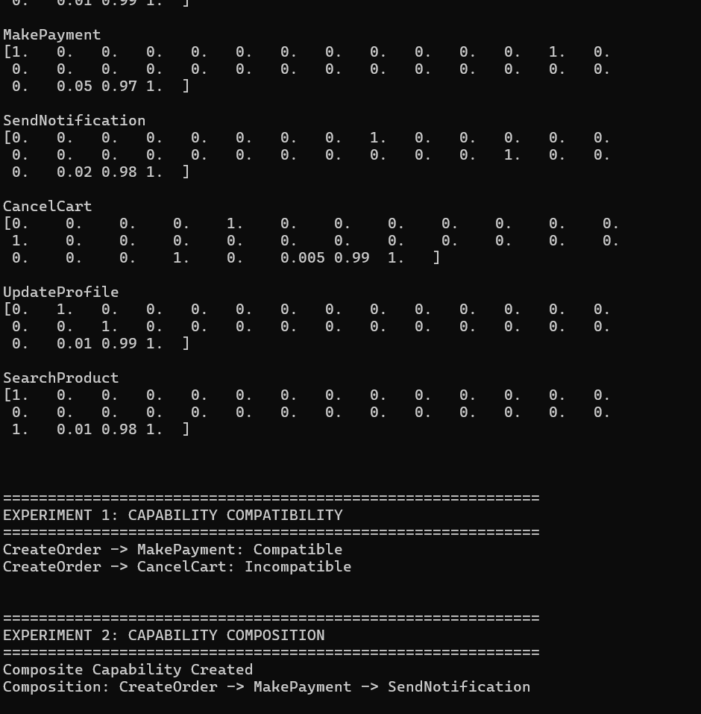
Figure 1: Encoded vectors and output of Experiment 1 (compatibility) and start of Experiment 2

9.2 Experiment 1: Capability compatibility
CreateOrder → MakePayment is reported as Compatible, because the effect OrderExists = true satisfies MakePayment’s precondition. CreateOrder → CancelCart is reported as Incompatible, because CancelCart requires OrderExists = false. The representation therefore distinguishes the composable pair from the non-composable pair, as required (Figure 1).

9.3 Experiment 2: Capability composition
The chain CreateOrder → MakePayment → SendNotification produced a composite capability. Its operational attributes follow the composition rules of Section 5.5:
Attribute | Result | Verification
Total cost | 0.08 | 0.01 + 0.05 + 0.02 = 0.08
Combined reliability | 0.9411 | 0.99 × 0.97 × 0.98 ≈ 0.9411
Availability | 1 | All three components available

The composite is lower in reliability than any single component, which correctly reflects that every step in the chain must succeed (Figure 2).
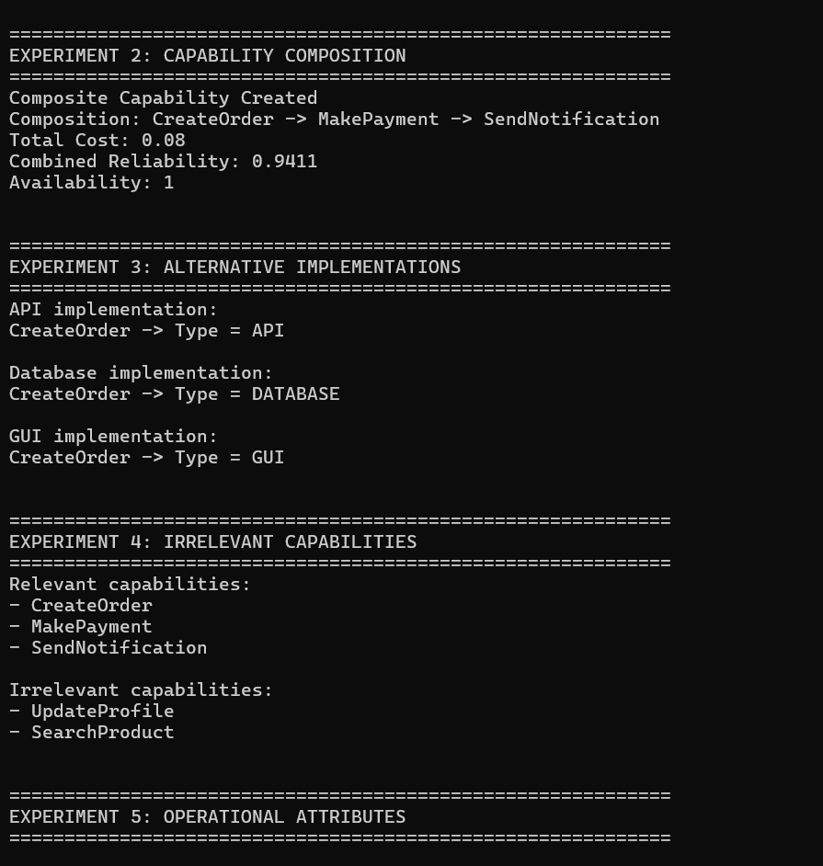
Figure 2: Results of Experiments 2, 3 and 4

9.4 Experiment 3: Alternative implementations
CreateOrder was defined through three mechanisms: API, DATABASE and GUI. All three describe the same functional outcome (creating an order) while differing in their type; the type block therefore separates them and they are not treated as identical, while the shared functional block keeps them functionally related (Figure 2).

9.5 Experiment 4: Irrelevant capabilities
CreateOrder, MakePayment and SendNotification were identified as relevant to the goal, while UpdateProfile and SearchProduct, which contribute to none of the goal conditions, were identified as irrelevant. The representation thus separates goal-contributing capabilities from unrelated ones (Figures 2 and 3).

9.6 Experiment 5: Operational attributes
Cost, reliability and availability were embedded explicitly as the final three dimensions of each vector, and all six capabilities were available (Availability = 1):
Capability | Cost | Reliability | Availability
CreateOrder | 0.01 | 0.99 | 1
MakePayment | 0.05 | 0.97 | 1
SendNotification | 0.02 | 0.98 | 1
CancelCart | 0.005 | 0.99 | 1
UpdateProfile | 0.01 | 0.99 | 1
SearchProduct | 0.01 | 0.98 | 1

9.7 Capability similarity
Capability pair | Cosine similarity
CreateOrder vs MakePayment | 0.5643
CreateOrder vs CancelCart | 0.3358
MakePayment vs SendNotification | 0.4938

CreateOrder is noticeably closer to MakePayment (0.5643), with which it composes, than to CancelCart (0.3358), with which it does not. The pairs that lie in the same purchase workflow have moderate similarity (about 0.5), whereas the conflicting pair has the lowest value. Similarity is therefore informative but is used only as a soft ranking signal; the compatibility test of Section 5.3 decides composability.

9.8 Efficiency
Metric | Value
Encoding time | 7.5 × 10⁻⁵ seconds
Number of capabilities | 6
Vector dimension | 32
Storage per capability | 32 floating-point values (≈ 256 bytes at float64)

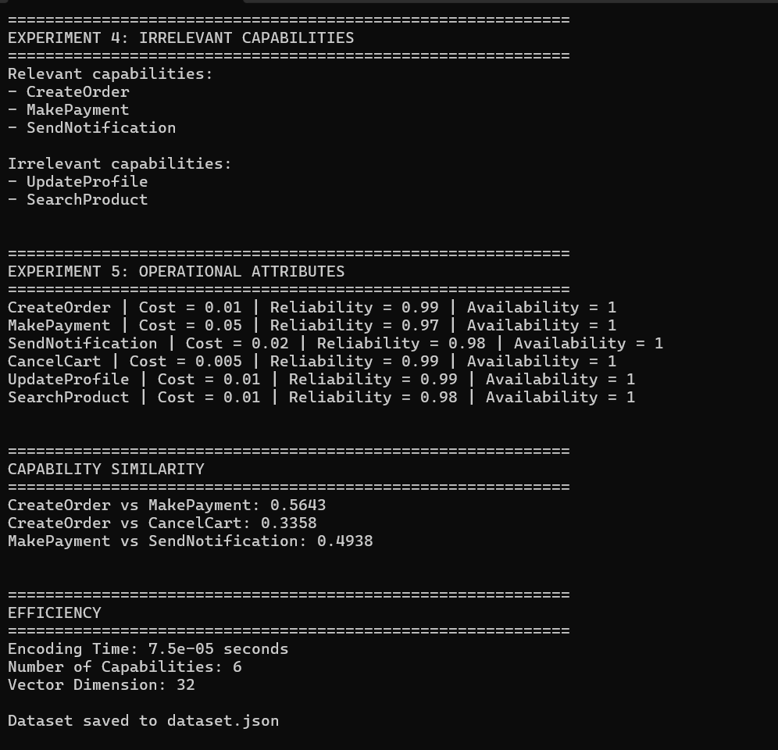
Figure 3: Results of Experiments 4 and 5, capability similarity, efficiency and dataset export

10. Analysis
The results are evaluated against the criteria listed in the assignment:
Property | Observation
Capability representation | All six capabilities produce distinct 32-dimensional vectors (Fig. 1).
State relationship | States and goals use the same feature space as capabilities, so their relationship to a capability can be compared directly.
Precondition–effect compatibility | CreateOrder → MakePayment is Compatible; CreateOrder → CancelCart is Incompatible (Exp. 1).
Input–output compatibility | Output/input indicators sit in the functional block, so dependencies between capabilities are representable.
Composition | The 3-step chain yields a composite with cost 0.08, reliability 0.9411 and availability 1 (Exp. 2).
Goal relevance | Relevant and irrelevant capabilities are separated (Exp. 4).
Operational properties | Cost, reliability and availability are stored explicitly and composed with exact rules (Exp. 5).
Consistency | The same encoding and rules were applied to all capabilities and all experiments without special cases.
Efficiency | Encoding takes about 7.5 × 10⁻⁵ s for 32 dimensions; memory and computation are negligible.

An important finding is that similarity and compatibility carry different information. CreateOrder is more similar to MakePayment than to CancelCart, but the deciding factor for composition is the logical relation Ei ⇒ Pj, not the cosine value. Keeping the two separate avoids false composition of merely similar capabilities.

11. Limitations
- The embedding is hand-designed and symbolic. It does not learn from data, so new predicates or capabilities require extending the feature vocabulary.
- The experimental domain is small (six capabilities). Scalability and robustness to large capability catalogues have not been tested.
- Compatibility currently relies on an explicit logical check; the vector alone does not guarantee Ei ⇒ Pj.
- Reliability of a composite assumes independent steps (product rule), and availability is static; time-dependent availability Ai(t) and risk/resource cost are not modelled.
- Goal relevance was evaluated as a categorical relevant / irrelevant split rather than a graded score, and numeric constraints (e.g. quantity ≤ inventory) are not embedded.
- Execution mechanism details (endpoint, table, component) are kept outside the main vector, so mechanism-level similarity is not captured.

12. Conclusion
This assignment designed and implemented a 32-dimensional, structure-preserving vector embedding for formally specified capabilities. The type block distinguishes implementation mechanisms, the functional block encodes what a capability needs and produces, and the operational block stores cost, reliability and availability explicitly. Experiments showed that the representation distinguishes composable from incompatible capabilities, builds a composite capability from a three-step chain with correct aggregated cost (0.08), reliability (0.9411) and availability (1), separates relevant from irrelevant capabilities, and is computationally trivial (≈ 7.5 × 10⁻⁵ s per encoding).
In answer to the primary research question, a suitably designed vector space can preserve the relationships needed for capability compatibility and composition, provided that geometric similarity is combined with an explicit precondition–effect test. Future work includes larger domains, graded goal-relevance scores, learned components on top of the symbolic features, and time-varying availability.

References
[1] T. Mikolov, K. Chen, G. Corrado, and J. Dean, “Efficient Estimation of Word Representations in Vector Space,” arXiv:1301.3781, 2013.
[2] PCCST503 Assignment 2: Design of a Vector Embedding for Capability Composition, course handout.

